Creating Github Actions Pipeline and testing code in SonarCloud

Open github.com and login into it. This is how github dashboard looks like.Choose New to create new repository.

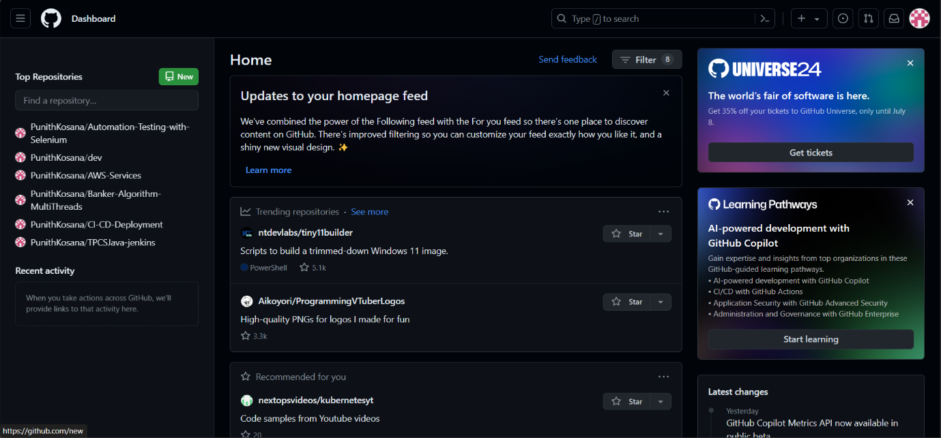

Name the repository and make it public, so that it is accessible to everyone. Choose create repository.

This is the index.html file that we are going to deploy into github pages and test the code in SonarCloud.

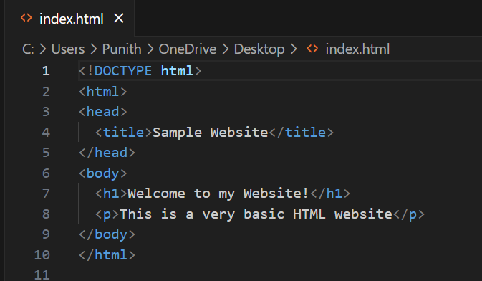

This is how website looks like.

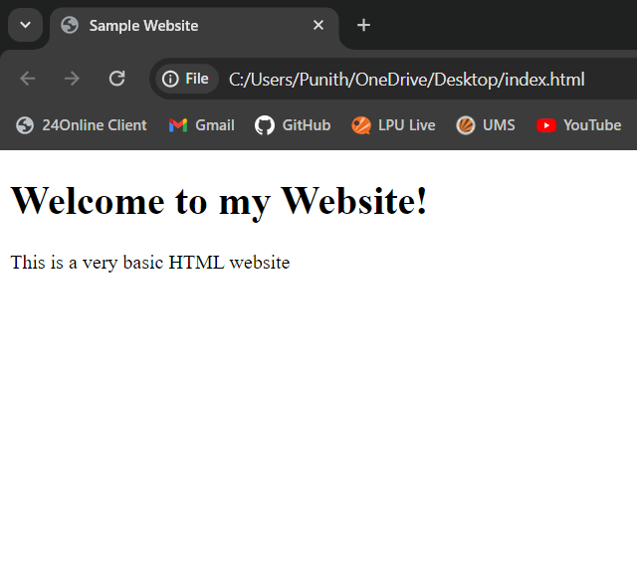

Add the file and commit changes.

The file is successfully pushed to the github repository.

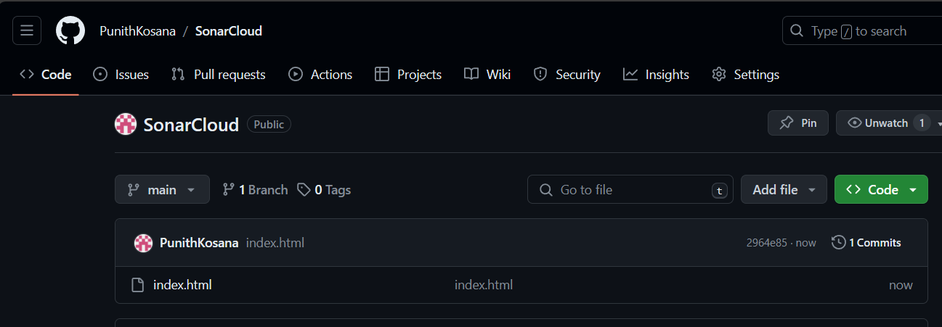

Now, open sonarcloud.io and login into it with github. Sonarcloud is an online version of SonarQube and it is an cloud-based platform to test the code and debug.

It will ask for login credentials of github. Enter them and choose sign in.

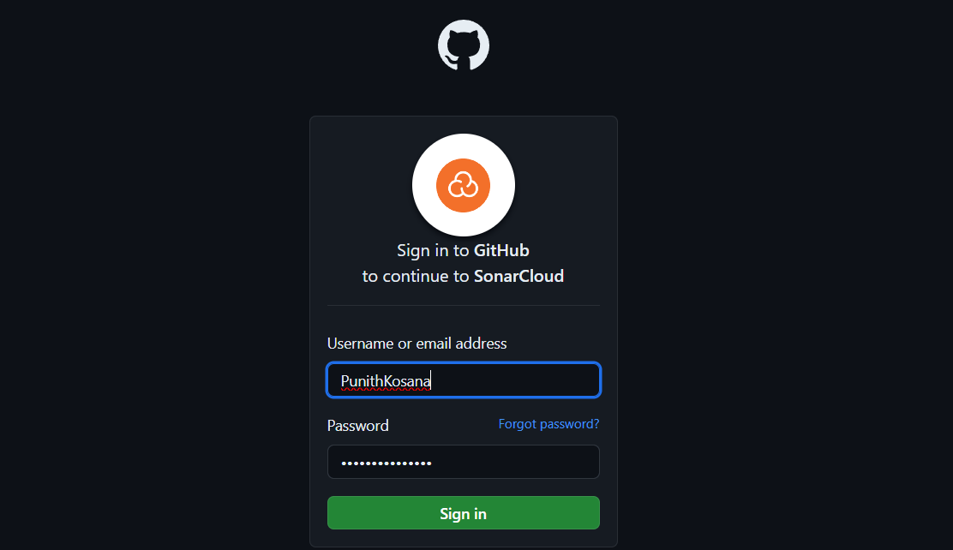

This is how sonarcloud dashboard looks like. Choose Analyse new project.

Choose import an organization from github.

Name the organization.

Choose free plan. And create organization.

Select the repository that have been created to test. Choose Set Up.

Choose previous version and create the project.

The project have been successfully created.

To analyze the project, add the Secret key to the repo from sonarcloud. Enter the details correctly of the Name and Value.

Go to Secrets and variables and choose actions. Choose new repository secret.

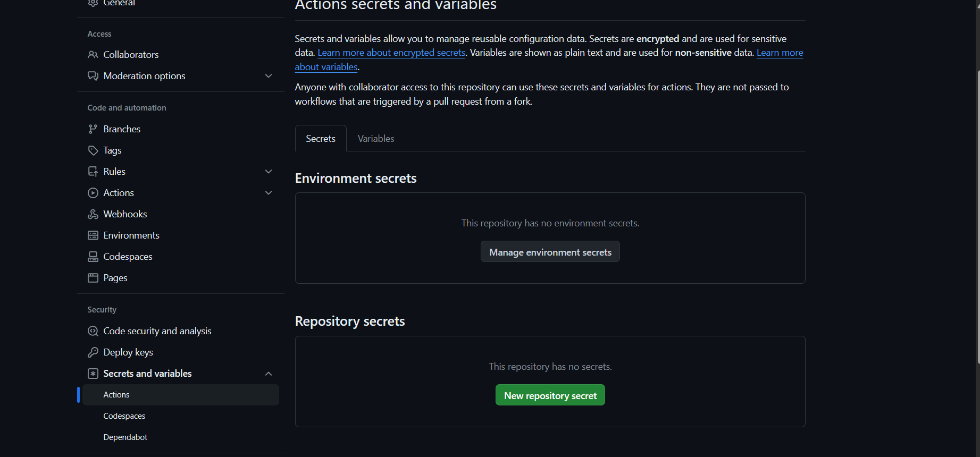

Enter the Name and Value from sonarcloud. Choose Add secret.

Go to setting of the repo and choose Github pages. Configure Static HTML to deploy the website into Github pages.

This is code used to deploy. Choose commit changes.

After committing changes, we can see the repo has build successfully and deployed to github pages.

We can see the website is live. Choose visit site.

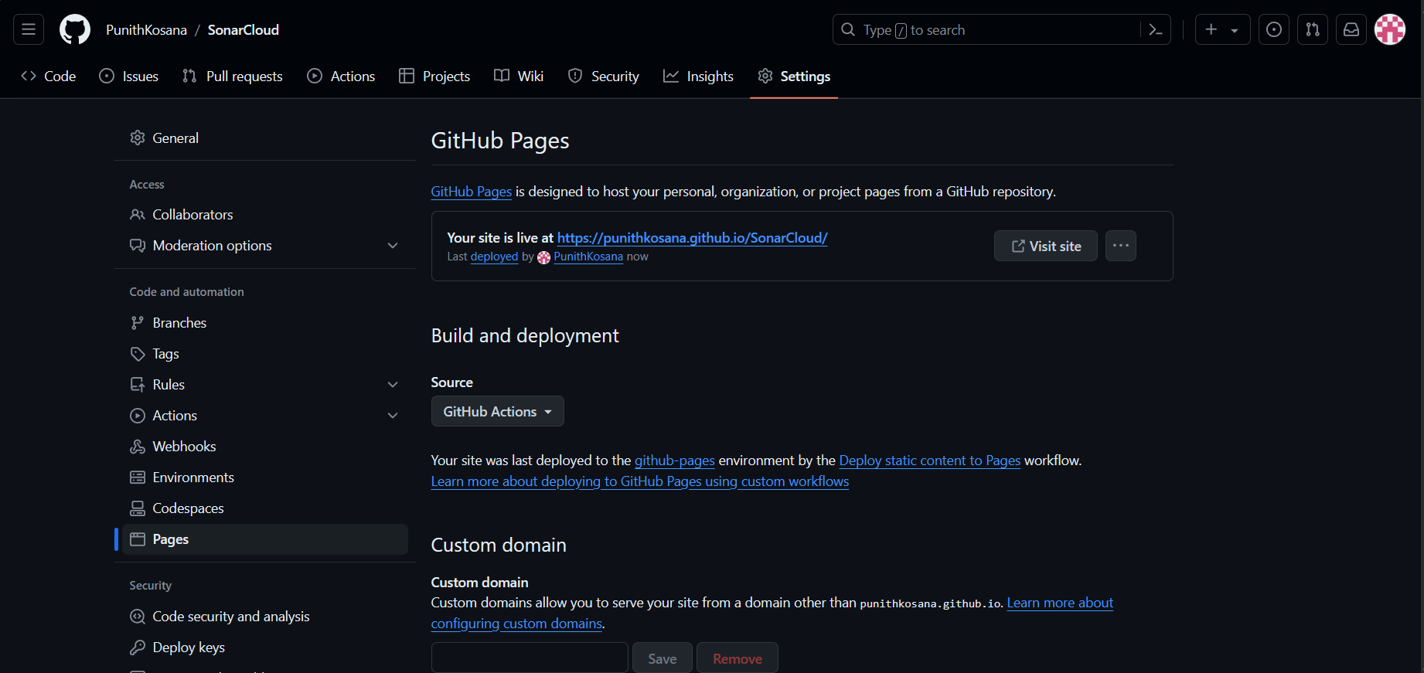

The website have been successfully deployed and we can see the url of website have been changed to the repository name.

Navigate to sonarcloud and we can see the code tests are passed.

